**NAME: MUHAMMAD IBRAHIM**

**Reg No: SP22-BCS-046**

**SECTION: A**

**Submitted To: Ma’am YASMEEN JANA**

**Subject: Data structure (LAB)**

**Question no 02: Implement stack using array?**

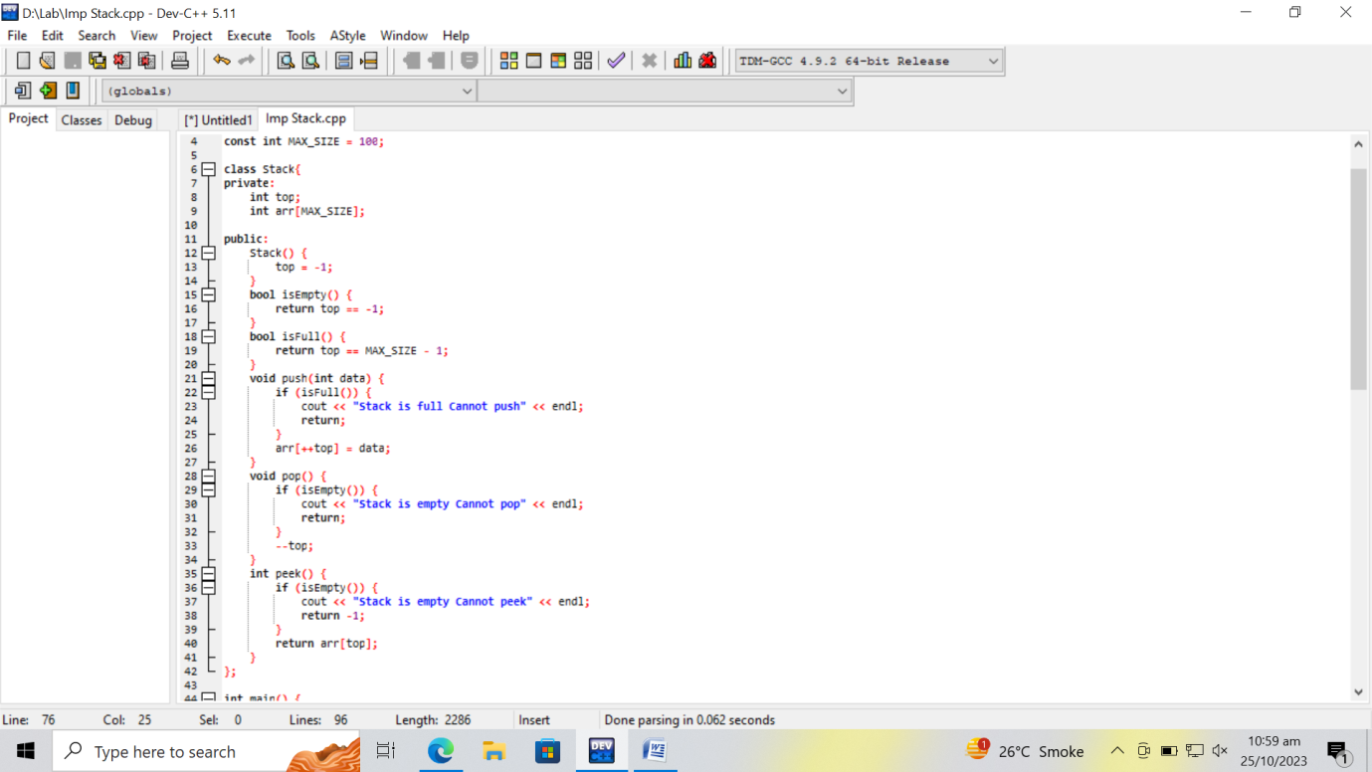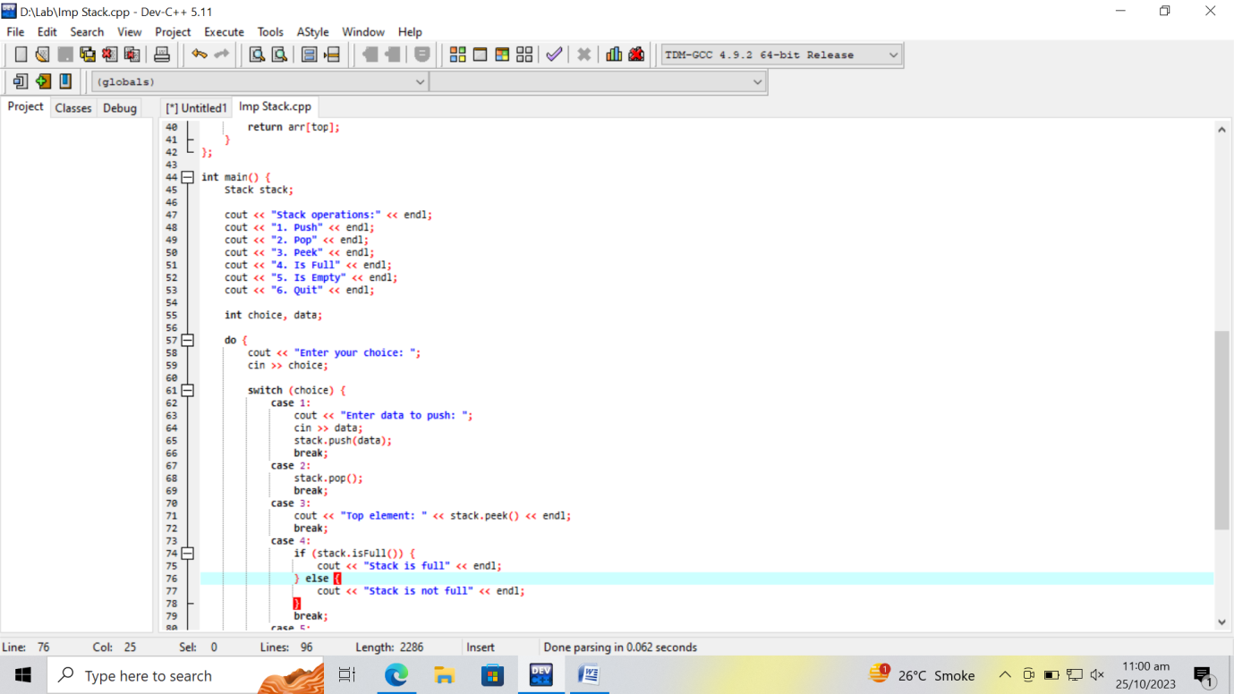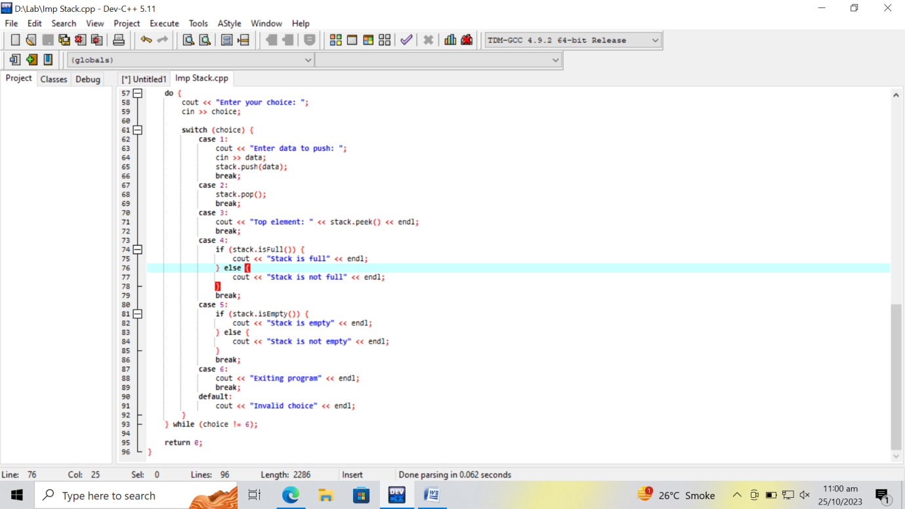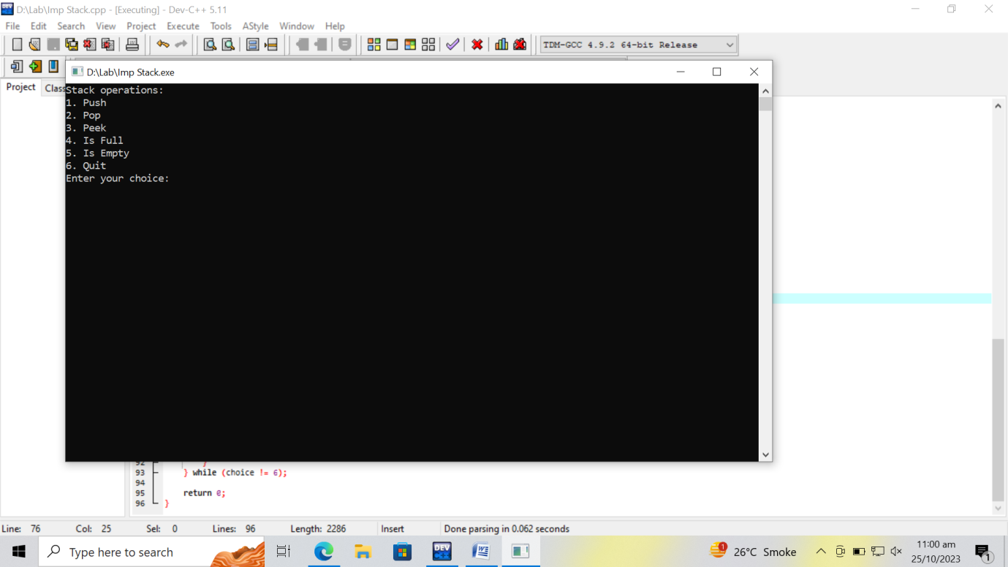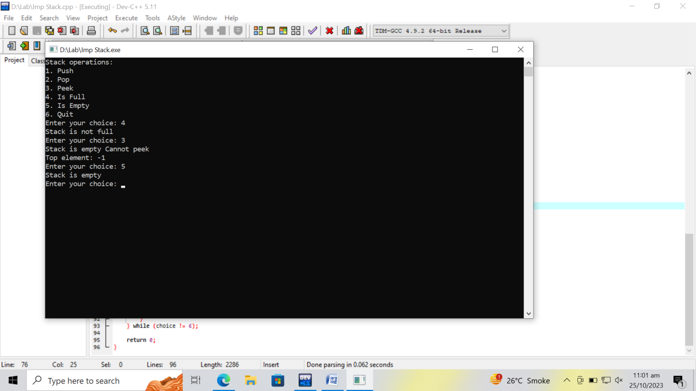

**Question no 01: To create a single linked list "SLL" function and "palindrome" function to check that single linked list is palindrome or not?**

